Ashbie B. Mweemba
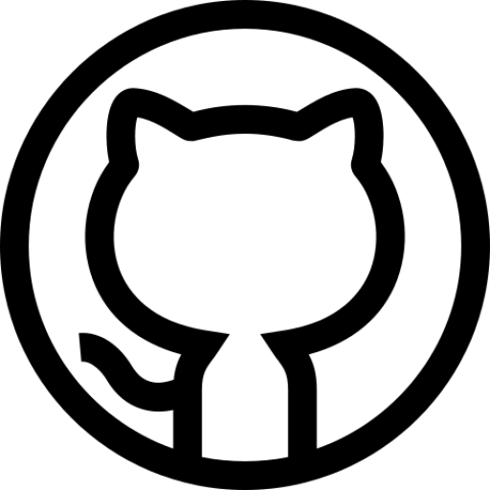

Front-End Software Engineer



ashbie.b.mweemba@gmail.com
+212627325528
www.ashbie.tech
github.com/ashbie

Projects

Jour-Par-Jour
May 2018 - Present // Boston, MA
▹ Write modern, performant, and robust code for a diverse array of client and internal projects
▹ Work with a variety of different languages, frameworks, and content management systems
such as JavaScript, TypeScript, React, Vue, NativeScript, Node.js, Craft, Prismic, etc.
▹ Communicate and collaborate with multi-disciplinary teams of engineers, designers, producers, clients, and stakeholders on a daily basis

Engineer @ Upstatement
May 2018 - Present // Boston, MA
▹ Write modern, performant, and robust code for a diverse array of client and internal projects
▹ Work with a variety of different languages, frameworks, and content management systems
such as JavaScript, TypeScript, React, Vue, NativeScript, Node.js, Craft, Prismic, etc.
▹ Communicate and collaborate with multi-disciplinary teams of engineers, designers, producers, clients, and stakeholders on a daily basis

Engineer @ Upstatement
May 2018 - Present // Boston, MA
▹ Write modern, performant, and robust code for a diverse array of client and internal projects
▹ Work with a variety of different languages, frameworks, and content management systems
such as JavaScript, TypeScript, React, Vue, NativeScript, Node.js, Craft, Prismic, etc.
▹ Communicate and collaborate with multi-disciplinary teams of engineers, designers, producers, clients, and stakeholders on a daily basis

Engineer @ Upstatement
May 2018 - Present // Boston, MA
▹ Write modern, performant, and robust code for a diverse array of client and internal projects
▹ Work with a variety of different languages, frameworks, and content management systems
such as JavaScript, TypeScript, React, Vue, NativeScript, Node.js, Craft, Prismic, etc.
▹ Communicate and collaborate with multi-disciplinary teams of engineers, designers, producers, clients, and stakeholders on a daily basis

Relevant Experience

Full-Stack PHP Developer @ EST Casablanca
March - May 2021 // Casablanca, MOROCCO
▹ Contributed to continuous integration and code revision history using Git.
▹ Helped solidify a brand direction for blistabloc to span across print, packaging, and web
▹ Interfaced with clients on a weekly basis, providing technological expertise and knowledge

Skills
Programming Languages JavaScript (ES6), TypeScript, HTML, CSS, GraphQL, PHP, C#, Python

Libraries & Frameworks
React, Node.js, Express, AntDesign, jQuery

Tools & Platforms
Git, Digital Ocean, Heroku, Webpack

Design
Adobe XD, Figma

Education

Sidi Mohamed Ben Abdellah University
2021 - 2022 // Fes, MOROCCO
Bachelor’s Degree in Software Engineering

Hassan II University
2019 - 2021 // Casablanca, MOROCCO
Diploma in Computer Engineering

David Kaunda Secondary School
2015 - 2017 // Lusaka, ZAMBIA
High School Diploma

Projects

Spotify Profile
Web app built with React, Node.js, and Express for visualizing personalized Spotify data such as top artists, tracks, recommendations, and audio features

Interests
Swimming, traveling, reading, ice-skating, skateboarding, biking, Marvel Cinematic Universe,

